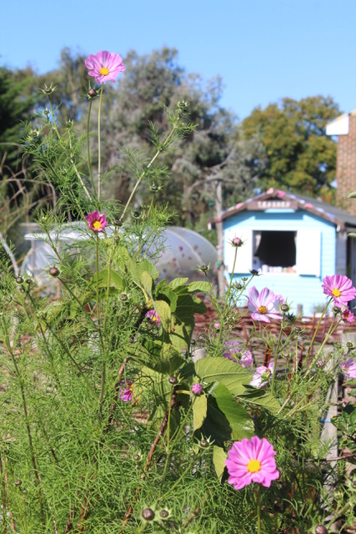
Stream Walk Community Garden Workshops

Proposal Form – Applicants New to SWCG
Your name.

Your contact details.

What is the name of your workshop and what does it cover?

What skills/experience do you have to run this workshop?

When do you want to do your workshop? (Please give timings and proposed date(s) )

At what time would you need access to the garden?

How many participants and volunteers are you looking to have?

And what would your ticket price be?

What materials/equipment would you bring along?

Would you need anything from us? (ie garden equipment)

Do you have any contingency plans if there was bad weather?

Are you insured to deliver on this site?

Lastly, what made you choose Stream walk Community Garden?

…and what do you think your workshop will bring to the garden?

Please add any information you feel would be of use to us.

Please email the completed form to veronicawheatley@mac.com

Thank you. We’ll be in touch.

